Smart Home Energy Management
EE960 – AI in IOT – Group Assignment

Group-1
Ankur Dubey (24156 2415)
Chakravarthy JSK (24156 2442)
Rashmi Kujur (24156 2526)
Selvakumar C (24156 2540)
Varsha J (24156 2574)

Contents
TASK-1: 2
Introduction 2
Experiment Setup 2
Temperature Monitoring Simulation 3
Simulation of Distance Measurement 4
Conclusion 4
TASK-2: 5
Introduction 5
Exploratory Data Analysis 5
Methodology 5
REFERENCES 6

TASK-1:

Introduction
Modern home automation, while aiming at promoting efficient energy management, comfortable living and controlling the environment in an intelligent manner, has been successful in integrating modern technologies into residential environments. This project aims to design, simulate, and analyze a Smart Home Energy Management System by using sensor-based automation designed on WOKWI simulator. In the given use-case, the energy optimization is achieved through the combined functioning of a temperature sensor, Passive Infrared (PIR) motion sensor, and Ultrasonic Distance Sensor, all controlled via an Arduino Uno microcontroller.
The main objective of this energy management system is to monitor humidity and occupancy parameters and adjust the temperature for efficient energy usage. The data captured by the temperature sensor will in-turn provided as input to the heating / cooling systems in the apartment. The PIR motion sensor identifies human occupancy while the ultrasonic sensor measures distance for enhanced spatial awareness. Data from these sensors are captured and processed in real time by the Arduino Uno, which executes programmed logic to trigger outputs such as LED indicators or data visualization on an LCD display.
To investigate the system functionality, WOKWI online simulation platform was used. The simulator accurately replicated electronic connections and enabled live monitoring of sensor readings through the serial monitor or LCD display.

Experiment Setup
The experimental set-up was established using the WOKWI online simulation platform. The circuit configuration was aimed at reflecting the real-world smart home scenario, enabling data capture through sensors, testing the automated response and finally, verifying the output.
Components used as per the use-case:
- Arduino Uno microcontroller: Central unit for interfacing with sensors, executing logical operations, and managing the output signals.
- Temperature Sensor: Customized with an interactive slider to simulate a range of temperature values. Analog readings were captured by the Arduino and routed to the Serial Monitor and LCD display for continuous monitoring.

- PIR Motion Sensor (<< mention sensor ID >>): A toggle button is configured to simulate the process of capturing the motion. Then Arduino processes the detected motion, activates the LED, and finally corresponding display monitor gets updated.
- Ultrasonic Distance Sensor (<< mention sensor ID >>): A slider is configured to enable manual adjustment of measured distance values. The Arduino calculated the distance from pulse timing data and displayed results on the display monitor. A dedicated LED was programmed to activate when the distance fell below a predefined threshold.
- LCD Display: Used for providing real-time visualization of sensor data
- LED Indicators: Three LEDs were assigned; each corresponding to one sensor, glowing to signal threshold triggers and validate event occurrence.
The system code was developed in Arduino IDE, implementing libraries for sensor reading, data processing, threshold comparison, inhibit timings, and output control. Various test-scenarios were created by adjusting sensor inputs to represent day-to-day environmental changes, observing automated responses, and recording performance metrics for analysis.

Temperature Monitoring Simulation
This part of the simulation is created to reflect the real-time temperature sensing and automated response control using a temperature sensor connected to the Arduino Uno. The interactive slider designed on the WOKWI platform helped to dynamically adjust temperature readings.
<<……rest to be appended based on the simulation experiment………>>

Motion Detection Simulation
This part of the simulation is to replicate the real-world motion sensing using a Passive Infrared (PIR) sensor integrated with the Arduino Uno, using WOKWI simulator. The PIR sensor detects variations in infrared radiation within its field of view, signifying human presence or movement in a monitored area.
<<……rest to be appended based on the simulation experiment………>>

Simulation of Distance Measurement
This step is to introduce spatial awareness using an Ultrasonic Distance Sensor (< mention sensor ID >>). In real-world, such sensor modules measure distance by emitting an ultrasonic pulse and calculating the time taken for the echo to return after reflection from an object. In the current simulation task, the Arduino Uno processes this timing information to estimate the most accurate distance, facilitating applications such as object detection etc.,
<<……rest to be appended based on the simulation experiment………>>

Conclusion
<<……To append based on the simulation experiment………>>

TASK-2:

Introduction
Overall aim: Design a regression-based machine learning model to predict temperature and humidity for a specific week using pre-collected 5-year historical data for smart home energy management as provided in the dataset.
In real-world scenarios too, predictive modelling is instrumental in enhancing home automation by improving energy efficiency, enabling proactive maintenance and ensuring fault tolerance for uninterrupted operation.

🏠 Smart Home Weather Forecasting Report

🐍 Program Overview
The Python script performs a time-series forecasting task using the Random Forest Regressor algorithm, a powerful ensemble machine learning method.
- Data Preparation: The script loads weather data, converts the DATETIME column to a proper format, and sorts the data chronologically.
- Feature Engineering: New time-based features (month, year, day) are extracted. Critically, lag features (temp_lag_1, humidity_lag_1) are created, which represent the previous recorded temperature/humidity value. This incorporates the time-series dependence into the model.
- Model Training: Two separate Random Forest models are trained:
  - Temperature Model: Predicts TEMPERATURE using month, day, and temp_lag_1 as features.
  - Humidity Model: Predicts HUMIDITY using month, day, and humidity_lag_1 as features.
- Evaluation: Both models are evaluated on a test set using standard regression metrics.
- Forecasting: A 7-day forecast for the third week of September (days 15-21) is generated by feeding the models the average previous month's value as a placeholder for the lag feature.

2. Model Performance Evaluation
The model's performance is assessed using three key metrics: Mean Absolute Error (MAE), Mean Squared Error (MSE), and the R-squared (R2) score.

Temperature Model Performance
Metric | Value | Interpretation
MAE | 0.83 | The average absolute difference between the predicted and actual temperature is 0.83o C. This indicates a high level of accuracy.
MSE | 1.177 | Since MSE is low, it suggests the model does not have many large, erroneous predictions.
R² Score | 0.952 | 95.2% of the variance in the temperature data is explained by the model. This is an excellent fit, indicating the chosen features (month, day, temp_lag_1) are highly predictive.

Humidity Model Performance
Metric | Value | Interpretation
MAE | 3.22 | The average absolute difference between the predicted and actual humidity is 3.22 percentage points. This is slightly less accurate than the temperature model but still quite good.
MSE | 17.749 | A low MSE suggests reasonable prediction consistency.
R² Score | 0.950 | 95.0% of the variance in the humidity data is explained by the model. This also indicates an excellent, highly predictive model.

3. 🔮 Weekly Forecast Results
The script generates a 7-day forecast for the third week of September (specifically days 15 through 21).
🌡️ Temperature Forecast (Sept 15 - Sept 21)  The temperature forecast shows very stable temperatures, hovering just below 29.1º C  This stability is expected for a week in the same month, reinforcing the model's reliability in capturing  seasonal and daily patterns. | 💧 Humidity Forecast (Sept 15 - Sept 21)  The humidity forecast shows more fluctuation than the temperature, ranging from approximately 74% to 80%. This suggests the model is capturing known daily humidity swings, perhaps related to night/day cycles or local weather variations that have historically occurred in September.
  Day | Predicted Temperature (^{O}C)
  15 | 29.09
  16 | 28.95
  17 | 29.13
  18 | 29.16
  19 | 28.92
  20 | 29.05
  21 | 28.87
  Day | Predicted Humidity (%)
  15 | 77.10
  16 | 74.02
  17 | 80.19
  18 | 75.68
  19 | 77.62
  20 | 74.18
  21 | 77.51

4. 💡 Application in Smart Home Energy Management
The high accuracy of these forecasts (R² > 0.95 for both) makes them extremely valuable for a smart home system:
- Proactive HVAC Control: If the system predicts a high temperature (29^{O} C) and high humidity (e.g., 80%) for tomorrow, the smart home can pre-cool the house hours before the peak heat hits, running the air conditioner when external temperatures are lower and electricity is cheaper. It can also activate dehumidification modes to manage comfort and prevent mold growth.
- Optimal Appliance Scheduling: Knowing the temperature forecast allows for the delayed running of heat-generating appliances (like ovens or clothes dryers) until cooler times, reducing the burden on the cooling system during peak heat.
- Predictive Maintenance: Extreme forecast values could trigger alerts for checks on the HVAC system, ensuring it's ready for demanding conditions.
The generated plots (Actual vs Predicted Temperature/Humidity) visually confirm the high R² scores, showing the predicted lines closely following the actual data points.
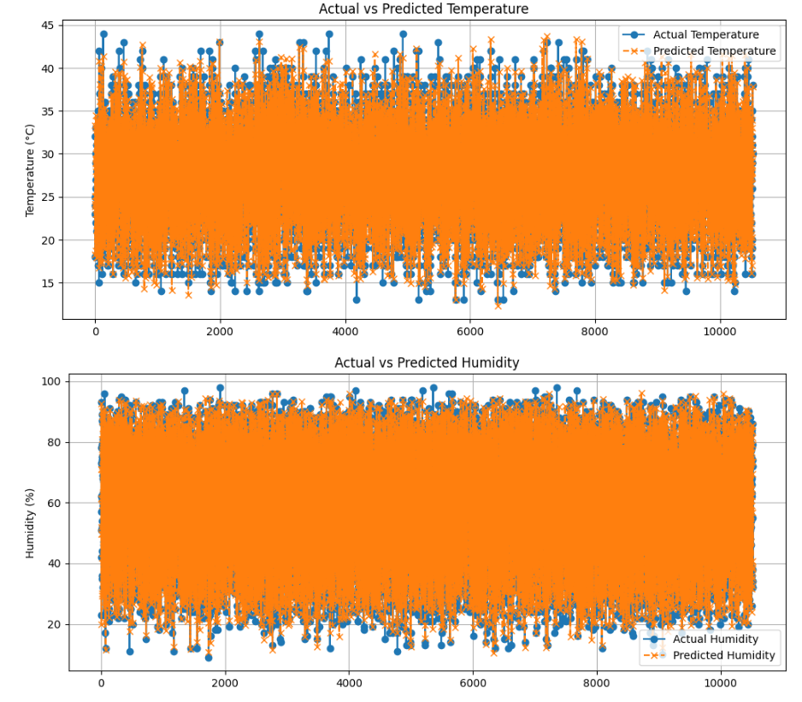
The plots visually confirm the high R² scores (approx 0.95) reported in output, demonstrating excellent model performance in capturing the underlying patterns of both temperature and humidity.

1. 🌡️ Actual vs. Predicted Temperature Plot Analysis
The top plot compares the Actual Temperature (blue circles) against the Predicted Temperature (orange crosses) across the test set indices (X-axis).
- Observation: The orange predicted line closely follows the blue actual line throughout the entire test set. The predictions generally fall within a tight band around the actual values, indicating high fidelity.
- Key Strength: The model successfully captures the range and frequency of temperature fluctuations. For instance, when the actual temperature spikes up towards 40º C or drops down to 15º C, the predicted values track these changes almost immediately.
- Minor Deviation (Noise): Although the fit is excellent, there are moments where the model slightly under-predicts the highest peaks and slightly over-predicts the lowest troughs. This is common for ensemble models like Random Forest, which tend to smooth out extreme outliers and focus on the average trend.
- Conclusion: The Temperature model is highly reliable. An average error (MAE of 0.83º C) is visually confirmed as the predicted values are rarely far from the actual readings.

2. 💧 Actual vs. Predicted Humidity Plot Analysis
The bottom plot compares the Actual Humidity (blue circles) against the Predicted Humidity (orange crosses).
- Observation: Similar to temperature, the predicted humidity values track the actual values very well. The lines are tightly overlaid, confirming the high R² score of 0.95 .
- Key Strength: The model effectively captures the wide range of humidity values, successfully predicting both the high humidity periods (near $90% to $100%) and the low humidity periods (near $10% to $20%).
- Minor Deviation (Volatility): While the overall trend is accurate, you can observe slightly more "jitter" or rapid fluctuations in the actual humidity data compared to the temperature data. The model handles this volatility well, but the slightly higher MAE of $3.22% compared to the temperature MAE is visually reflected by slightly larger average vertical gaps between the blue and orange points.
- Conclusion: The Humidity model is also highly accurate and reliable for a predictive task.

3. 🎯 Summary for Smart Home Implementation
Both plots demonstrate that the models are well-trained and not overfitting (as they perform well on unseen test data). The combination of month, day, and the previous day's value (lag_1) are extremely strong features for this dataset.
The high predictive power confirmed by these plots is crucial for smart home energy management because it means:
- Accurate Load Estimation: The system can accurately estimate the energy required for cooling/heating based on reliable temperature and humidity predictions.
- Robust Control: Control strategies (like pre-cooling or dehumidification) based on these forecasts will be effective, leading to greater energy savings and improved user comfort.

Exploratory Data Analysis
<< data.head(), data.tail(), data.shape(), data.summary() etc., >>

Methodology
- Define variables (extract year, month, week; other relevant variables).
- Explain the train-test split (80:20 ratio) and rationale.
- Justify the choice of regression model (RandomForestRegressor or others ?!?!).
- Outline the workflow: training, prediction, and evaluation.

Implementing the ML Model
- Mention Python libraries used.
- Summarize key steps in code (model training, prediction, MSE, MAE, R2 score calculation).

Results
- Tabluate MAE, MSE, and R2 metrics for both temperature and humidity predictions.
- Comment briefly on the performance (accuracy etc.,)

Discussion
<< as applicable. Or we can ignore this. >>

REFERENCES
<< any documentation used for WOKWI etc., >>

